Datasheet


L-5RA7
5G Ultraband Hinged Monople Blade Antenna

CELLULAR
WIFI

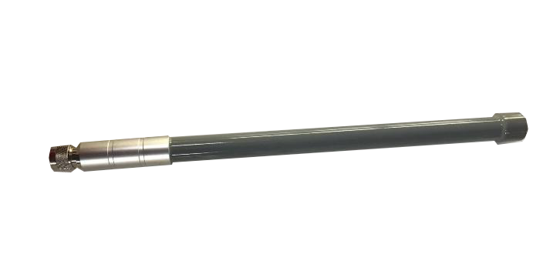
The L-5RA7 is an ultraband antenna for 5G, LTE, and WCDMA that can also cover Wi-Fi frequencies. It’s a compact and durable external antenna with a wide band and high efficiency.

The L-5RA7 allows the antenna to be positioned for optimum performance compared to a fixed whip design. The antenna attaches with an SMA connector.

320x 20 mm

www.miotsolutions.com
info@miotsolutions.com

Document Information

Product | L-5RA7
Part Number | L-5RA7
Description | 5G Ultraband Hinged Monople Blade Antenna
Version | 2.0 (current)
Date | 29-June-2023
Status | Released

Revision History

Version | Date | Author | Changes
1.0 | 16-Dec-2020 | Amy Li | Initial Release
2.0 | 29-June-2023 | Ivy Liao | New layout and design

Product Overview

Product Description |  | Key Features
The L-5RA7 is an ultraband hinged monopole blade cellular antenna for 5G, LTE, and WCDMA that can also cover Wi-Fi frequencies. It’s a compact and durable external antenna with an ultra-wide range and high efficiency. It’s an ideal solution for cellular IoT applications requiring a durable and cost-effective external antenna.  The hinged swivel design allows the antenna to be positioned for optimum performance and reduces the potential for damage from impact compared to a fixed blade design. The antenna attaches with an SMA plug (male pin) connector. |  | - Support LTE/5G bands  - Small and exquisite  - High Reliability/Sensitivity  - Compact Size, Easy to install  - IP Rating 66  - RoHS Compliant
 |  | Applications
- ISM Outdoor
- Gateways
- Set-Top Boxes
- Security
- Signal repeater
- Smart agriculture

Electrical Specifications

Frequency |  |  |  |  | VSWR | Peak Gain | Efficiency
5G/LTE | 700 | - | 960 | MHz | 2.5 | 1.2 d Bi | 52%
5G/LTE | 1710 | - | 2170 | MHz | 2.0 | 2.0 d Bi | 55%
5G/LTE | 2300 |  | 2700 | MHz | 2.2 | 1.0 d Bi | 50%
5G/LTE | 3000 |  | 5000 | MHz | 2.4 | 1.2 d Bi | 35%

Frequency Range | 700 – 5000 MHz |  | Radiation | Omnidirectional
Impedance | 50 Ω |  | Electrical Type | Monopole
Polarization | Linear

Mechanical Specifications

Type | Hinge / Swivel Blade Type |  | Casing | Yes
Dimensions | 320x 20 mm |  | Color | Black
Connector (Termination) | N male |  | Material | PC + ABS
Mounting Type | Connector Mount |  | Weight | TBC (to be confirmed)

Caution:
- Do not apply excess mechanical stress to the component body or terminations. Do not attempt to re-form or bend the components, as this will cause damage to the component.
- Do not expose the component to an open flame.
- This specification applies to the functionality of the component as a single unit. Please ensure the component is thoroughly evaluated in the application circuit.

Product Image and Dimensions

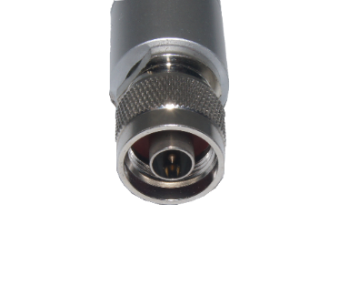

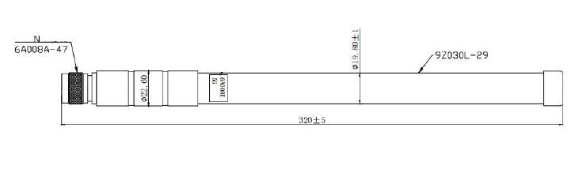

Environmental Data

Operating Temperature | -40 °C to +85 °C
IP Rating | IP66
Compliance | RoHS

Ordering Information

Product Variants

Part Number | Description
L-5RA3 | 5G Ultraband Hinged Monople Blade Antenna

About MIOT

Miot Wireless Solutions, headquartered in Suzhou, China, was established in 2017. It has subsidiaries in Canada, the United States, Brazil, and EMEA. MIOT is a professional designer and manufacturer of Antennas and IoT PCBA products, providing turn-key service to customers worldwide.

Our talented R&D team has experienced antenna, hardware, and software engineers who can participate in your new project, from something simple like antenna/selection and design, to complete turn-key services, which entails taking your concept and ideas through design, prototyping, debugging, certification, and manufacturing. Miot offers reliable products at reasonable prices with fast delivery times to help you get ahead in the market.

Contact

MIOT Wireless Solutions Co. Ltd.
120-5800 Ambler Dr, MISSISSAUGA
ONTARIO L4W 4J4
Canada

Website: www.miotsolutions.com
Email: info@miotsolutions.com

The information contained herein is provided “as is” and MOIT assumes no liability for using the information. No warranty, either express or implied, is given, including but not limited to the accuracy, correctness, reliability, and fitness for a particular purpose of the information. This document may be revised by MOIT at any time.

MIOT reserves all rights to this document and the information contained herein. Reproduction, use, modification, or disclosure to third parties of this document without express permission is strictly prohibited.

Copyright © 2023, MIOT Wireless Solutions Ltd. All Rights Reserved


www.miotsolutions.com

