Datasheet


L-5RA3
5G Ultraband Hinged Monople Blade Antenna

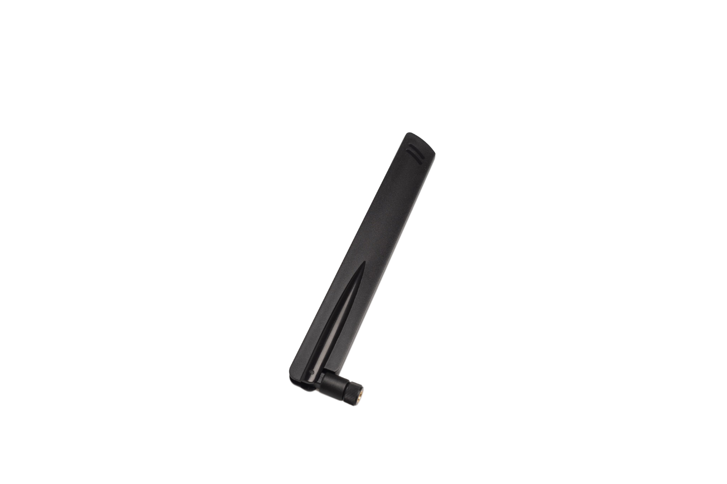
CELLULAR
WIFI

The L-5RA3 is an ultraband antenna for 5G, LTE, and WCDMA that can also cover Wi-Fi frequencies. It’s a compact and durable external antenna with a wide band and high efficiency.

The L-5RA3 allows the antenna to be positioned for optimum performance compared to a fixed whip design. The antenna attaches with an SMA connector.

195 x 26 x 13 mm

www.miotsolutions.com
info@miotsolutions.com

Document Information

Product | L-5RA3
Part Number | L-5RA3
Description | 5G Ultraband Hinged Monople Blade Antenna
Version | 2.0 (current)
Date | 30-Mar-2023
Status | Released

Revision History

Version | Date | Author | Changes
1.0 | 16-Dec-2020 | Amy Li | Initial Release
2.0 | 30-Mar-2023 | Amy Li | New layout and design

Product Overview

Product Description |  | Key Features
The L-5RA3 is an ultraband hinged monopole blade cellular antenna for 5G, LTE, and WCDMA that can also cover Wi-Fi frequencies. It’s a compact and durable external antenna with an ultra-wide range and high efficiency. It’s an ideal solution for cellular IoT applications requiring a durable and cost-effective external antenna.  The hinged swivel design allows the antenna to be positioned for optimum performance and reduces the potential for damage from impact compared to a fixed blade design. The antenna attaches with an SMA plug (male pin) connector. |  | - Supports 5G / LTE / WCDMA & WIFI  - Wide Application  - High Reliability/Sensitivity  - Compact Size, Easy to install.  - RoHS Compliant
 |  | Applications
- LTE/Wi-Fi Radios
- Gateways
- Set-top Boxes.
- Security
- Transportation
- Smart Agriculture

Electrical Specifications

Frequency |  |  |  |  | VSWR | Peak Gain | Efficiency
5G/LTE | 690 | - | 960 | MHz | 1.8 | 2.0 d Bi | 40%
5G/LTE | 1710 | - | 5000 | MHz | 2.8 | 1.9 d Bi | 50%
2.4G WiFi | 2400 |  | 2500 | MHz | 4.0 | 6.0 d Bi | 60%

Frequency Range | 690 – 5000 MHz |  | Radiation | Omnidirectional
Impedance | 50 Ω |  | Electrical Type | Monopole
Polarization | Linear

Mechanical Specifications

Type | Hinge / Swivel Blade Type |  | Casing | Yes
Dimensions | 195 x 26 x 13 mm |  | Color | Black
Connector (Termination) | SMA Plug (male pin) |  | Material | PC + ABS
Mounting Type | Connector Mount |  | Weight | TBC (to be confirmed)

Caution:
- Do not apply excess mechanical stress to the component body or terminations. Do not attempt to re-form or bend the components, as this will cause damage to the component.
- Do not expose the component to an open flame.
- This specification applies to the functionality of the component as a single unit. Please ensure the component is thoroughly evaluated in the application circuit.

Product Image and Dimensions

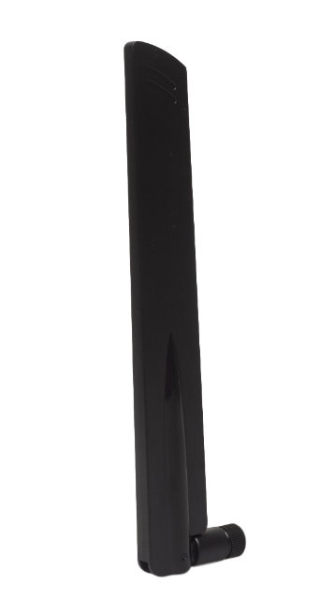 | 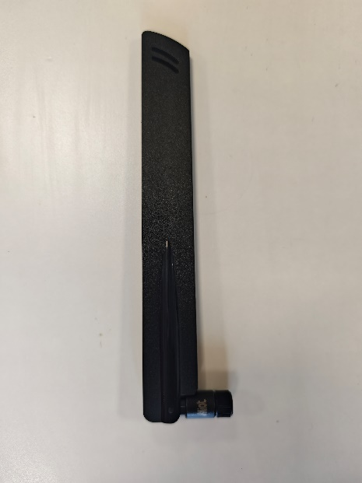 | 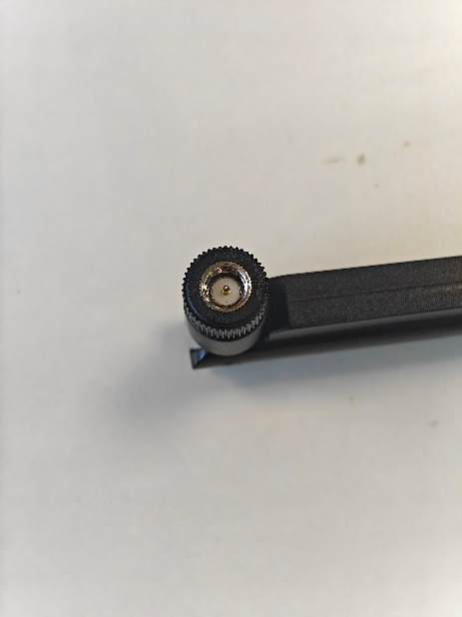

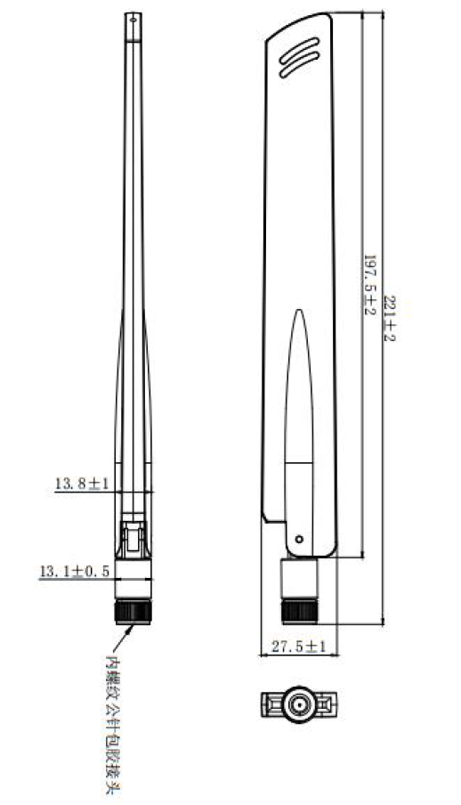

Radiation Pattern

A radiation pattern is a graphical representation of the directional properties of an antenna. It shows how electromagnetic waves are distributed in space in relation to the direction of propagation.

By understanding the information provided by a radiation pattern, it is possible to optimize the design and performance of an antenna for specific applications.
XY Plane (H) |  | 690 – 5000 MHz

YZ Plane (E1) |  | 690 – 5000 MHz

YZ Plane (E2) |  | 690 – 5000 MHz

Antenna Smith and VSWR

Frequency |  | VSWR |  | Frequency |  | VSWR
699 | MHz | 1.87 |  | 2700 | MHz | 3.50
960 | MHz | 1.84 |  | 3300 | MHz | 3.72
1710 | MHz | 1.71 |  | 3840 | MHz | 1.72
2170 | MHz | 2.13 |  | 5000 | MHz | 3.19
2400 | MHz | 3.95

Antenna Efficiency and Gain
Frequency |  | Efficiency | Gain |  | Frequency |  | Efficiency | Gain
699 | MHz | 47% | 2.222029 |  | 2400 | MHz | 55% | 1.753213
700 | MHz | 48% | 2.371552 |  | 2450 | MHz | 55% | 1.992987
720 | MHz | 46% | 2.624219 |  | 2500 | MHz | 54% | 1.580275
740 | MHz | 44% | 2.275144 |  | 2550 | MHz | 54% | 1.579621
760 | MHz | 40% | 1.897427 |  | 2600 | MHz | 54% | 1.465552
780 | MHz | 41% | 2.078508 |  | 2650 | MHz | 56% | 2.258436
800 | MHz | 44% | 2.431603 |  | 2700 | MHz | 54% | 1.931343
820 | MHz | 43% | 2.140184 |  | 3000 | MHz | 46% | 1.18906
840 | MHz | 39% | 1.879236 |  | 3100 | MHz | 46% | 2.067313
860 | MHz | 38% | 2.005644 |  | 3200 | MHz | 44% | 2.171236
880 | MHz | 40% | 1.958402 |  | 3300 | MHz | 52% | 2.735201
900 | MHz | 45% | 2.102504 |  | 3400 | MHz | 58% | 3.30725
920 | MHz | 47% | 2.337229 |  | 3500 | MHz | 60% | 4.544507
940 | MHz | 46% | 1.972035 |  | 3600 | MHz | 66% | 6.243625
960 | MHz | 48% | 2.313829 |  | 3700 | MHz | 74% | 6.480988
1710 | MHz | 62% | 7.24509 |  | 3800 | MHz | 76% | 5.309328
1750 | MHz | 60% | 6.483171 |  | 3900 | MHz | 65% | 4.817564
1790 | MHz | 60% | 7.287877 |  | 4000 | MHz | 60% | 4.003033
1830 | MHz | 59% | 6.503151 |  | 4100 | MHz | 62% | 4.164623
1870 | MHz | 59% | 5.415894 |  | 4200 | MHz | 66% | 4.891869
1900 | MHz | 62% | 5.068743 |  | 4300 | MHz | 69% | 5.011474
1930 | MHz | 64% | 4.607269 |  | 4400 | MHz | 60% | 5.269234
1960 | MHz | 60% | 3.764602 |  | 4500 | MHz | 47% | 4.576191
1990 | MHz | 62% | 4.387311 |  | 4600 | MHz | 48% | 4.486405
2100 | MHz | 59% | 4.531283 |  | 4700 | MHz | 55% | 4.284654
2130 | MHz | 61% | 4.563667 |  | 4800 | MHz | 64% | 5.286538
2170 | MHz | 59% | 4.518664 |  | 4900 | MHz | 63% | 5.265667
2300 | MHz | 63% | 3.449054 |  | 5000 | MHz | 53% | 4.627859
2350 | MHz | 57% | 2.3842

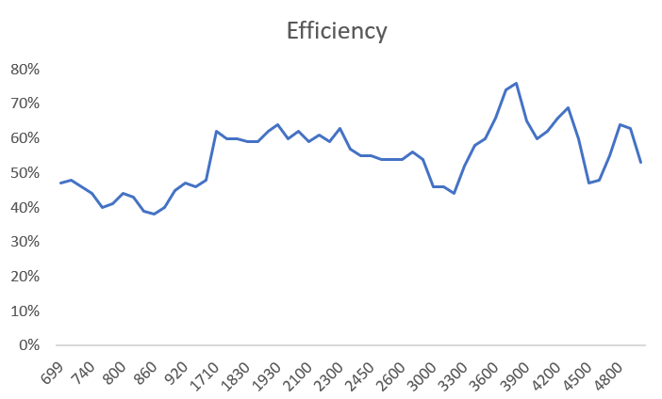

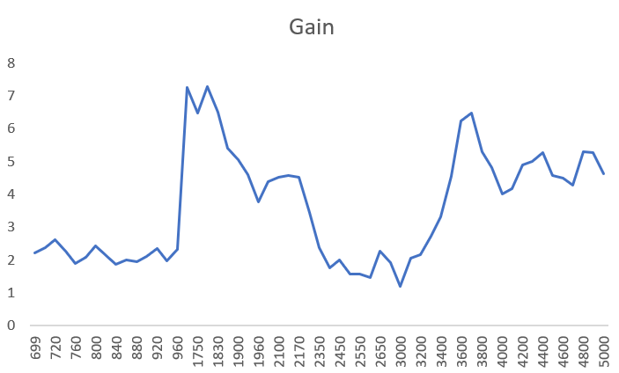

Environmental Data

Operating Temperature | -20 °C to +80 °C
IP Rating | IP55
Compliance | RoHS

Ordering Information

Product Variants

Part Number | Description
L-5RA3 | 5G Ultraband Hinged Monople Blade Antenna

About MIOT

Miot Wireless Solutions, headquartered in Suzhou, China, was established in 2017. It has subsidiaries in Canada, the United States, Brazil, and EMEA. MIOT is a professional designer and manufacturer of Antennas and IoT PCBA products, providing turn-key service to customers worldwide.

Our talented R&D team has experienced antenna, hardware, and software engineers who can participate in your new project, from something simple like antenna/selection and design, to complete turn-key services, which entails taking your concept and ideas through design, prototyping, debugging, certification, and manufacturing. Miot offers reliable products at reasonable prices with fast delivery times to help you get ahead in the market.

Contact

MIOT Wireless Solutions Co. Ltd.
120-5800 Ambler Dr, MISSISSAUGA
ONTARIO L4W 4J4
Canada

Website: www.miotsolutions.com
Email: info@miotsolutions.com

The information contained herein is provided “as is” and MOIT assumes no liability for using the information. No warranty, either express or implied, is given, including but not limited to the accuracy, correctness, reliability, and fitness for a particular purpose of the information. This document may be revised by MOIT at any time.

MIOT reserves all rights to this document and the information contained herein. Reproduction, use, modification, or disclosure to third parties of this document without express permission is strictly prohibited.

Copyright © 2023, MIOT Wireless Solutions Ltd. All Rights Reserved


www.miotsolutions.com

