Datasheet

L-5RA7

5G Ultraband Hinged Monople Blade Antenna

CELLULAR

WIFI

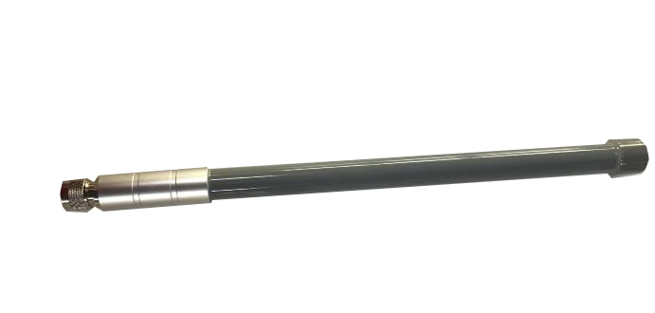

The L-5RA7 is an ultraband antenna for 5G, LTE, and WCDMA that can also cover Wi-Fi frequencies. It’s a compact and durable external antenna with a wide band and high efficiency.

The L-5RA7 allows the antenna to be positioned for optimum performance compared to a fixed whip design. The antenna attaches with an SMA connector.

320x 20 mm

www.miotsolutions.com

info@miotsolutions.com

# Document Information

|  |  |
| --- | --- |
| Product | L-5RA7 |
| Part Number | L-5RA7 |
| Description | 5G Ultraband Hinged Monople Blade Antenna |
| Version | 2.0 (current) |
| Date | 29-June-2023 |
| Status | Released |

# Revision History

|  |  |  |  |
| --- | --- | --- | --- |
| Version | Date | Author | Changes |
| 1.0 | 16-Dec-2020 | Amy Li | Initial Release |
| 2.0 | 29-June-2023 | Ivy Liao | New layout and design |

# Product Overview

|  |  |  |
| --- | --- | --- |
| Product Description |  | Key Features |
| The L-5RA7 is an ultraband hinged monopole blade cellular antenna for 5G, LTE, and WCDMA that can also cover Wi-Fi frequencies. It’s a compact and durable external antenna with an ultra-wide range and high efficiency. It’s an ideal solution for cellular IoT applications requiring a durable and cost-effective external antenna. The hinged swivel design allows the antenna to be positioned for optimum performance and reduces the potential for damage from impact compared to a fixed blade design. The antenna attaches with an SMA plug (male pin) connector. |  | * Support LTE/5G bands * Small and exquisite * High Reliability/Sensitivity * Compact Size, Easy to install * IP Rating 66 * RoHS Compliant |
|  | Applications |
|  | * ISM Outdoor * Gateways * Set-Top Boxes * Security * Signal repeater * Smart agriculture |

# Electrical Specifications

|  |  |  |  |  |  |  |  |
| --- | --- | --- | --- | --- | --- | --- | --- |
| Frequency | | | | | VSWR | Peak Gain | Efficiency |
| 5G/LTE | 700 | - | 960 | MHz | 2.5 | 1.2 d Bi | 52% |
| 5G/LTE | 1710 | - | 2170 | MHz | 2.0 | 2.0 d Bi | 55% |
| 5G/LTE | 2300 |  | 2700 | MHz | 2.2 | 1.0 d Bi | 50% |
| 5G/LTE | 3000 |  | 5000 | MHz | 2.4 | 1.2 d Bi | 35% |

|  |  |  |  |  |
| --- | --- | --- | --- | --- |
| Frequency Range | 700 – 5000 MHz |  | Radiation | Omnidirectional |
| Impedance | 50 Ω |  | Electrical Type | Monopole |
| Polarization | Linear |  |  |  |

# Mechanical Specifications

|  |  |  |  |  |
| --- | --- | --- | --- | --- |
| Type | Hinge / Swivel Blade Type |  | Casing | Yes |
| Dimensions | 320x 20 mm |  | Color | Black |
| Connector (Termination) | N male |  | Material | PC + ABS |
| Mounting Type | Connector Mount |  | Weight | TBC (to be confirmed) |

Caution:

1. Do not apply excess mechanical stress to the component body or terminations. Do not attempt to re-form or bend the components, as this will cause damage to the component.
2. Do not expose the component to an open flame.
3. This specification applies to the functionality of the component as a single unit. Please ensure the component is thoroughly evaluated in the application circuit.

# Product Image and Dimensions

|  |  |  |
| --- | --- | --- |
| C:\Users\ThinkPad\Desktop\2.png |  |  |

|  |
| --- |
|  |
|  |

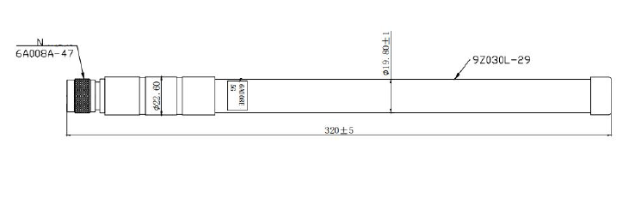

# Environmental Data

|  |  |
| --- | --- |
| Operating Temperature | -40 °C to +85 °C |
| IP Rating | IP66 |
| Compliance | RoHS |

# Ordering Information

## Product Variants

|  |  |
| --- | --- |
| Part Number | Description |
| L-5RA3 | 5G Ultraband Hinged Monople Blade Antenna |

# About MIOT

|  |
| --- |
| Miot Wireless Solutions, headquartered in Suzhou, China, was established in 2017. It has subsidiaries in Canada, the United States, Brazil, and EMEA. MIOT is a professional designer and manufacturer of Antennas and IoT PCBA products, providing turn-key service to customers worldwide.  Our talented R&D team has experienced antenna, hardware, and software engineers who can participate in your new project, from something simple like antenna/selection and design, to complete turn-key services, which entails taking your concept and ideas through design, prototyping, debugging, certification, and manufacturing. Miot offers reliable products at reasonable prices with fast delivery times to help you get ahead in the market. |
|
|

# Contact

MIOT Wireless Solutions Co. Ltd.

120-5800 Ambler Dr, MISSISSAUGA

ONTARIO L4W 4J4

Canada

Website: www.miotsolutions.com

Email: info@miotsolutions.com

The information contained herein is provided “as is” and MOIT assumes no liability for using the information. No warranty, either express or implied, is given, including but not limited to the accuracy, correctness, reliability, and fitness for a particular purpose of the information. This document may be revised by MOIT at any time.

MIOT reserves all rights to this document and the information contained herein. Reproduction, use, modification, or disclosure to third parties of this document without express permission is strictly prohibited.

Copyright © 2023, MIOT Wireless Solutions Ltd. All Rights Reserved



www.miotsolutions.com